Practice – Machines

- It is thought by many that machines work by amplifying (multiplying) the work that is put into them so that more work

comes out, thus making work easier. Explain why this is a misconception. ___________________________________

________________________________________________________________________________________________

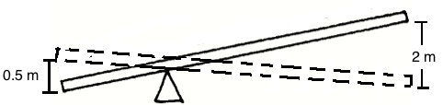
- Two clowns, of mass 50.0 kg and 70.0 kg respectively, are in a circus act performing a stunt with a trampoline and a seesaw. The smaller clown stands on the lower end of the seesaw while the larger clown jumps from the trampoline onto the raised side of the seesaw, propelling his friend into the air. If the larger clown exerts a force of 850. N down on the seesaw when he hits it, how much force is exerted on the smaller clown? (Ignore F_{f})

- The Ramseys are moving to a new town, so they have called in the ACME moving company to take care of their furniture. Debbie, one of the movers, slides the Ramseys’ 2.20 x 10³ N china cabinet up a 6.00 m long ramp to the moving van, which stands 1.00 m off the ground.
  - What is the ideal mechanical advantage of the incline? (Ignore F_{f})

  - If Debbie must exert a 500. N force to move the china cabinet up the ramp with a constant speed, what is the efficiency of the ramp?

  - Assuming all energy loss is due to work done by friction, according to the information in “B” above, how much energy went to heating the environment while moving the cabinet up the ramp?

