Practice – Conservation of Momentum Model

- Suppose you are traveling in a bus at highway speed and the momentum of an unlucky bug is suddenly changed as it splatters onto the front window. During the interaction, which, the bug or the bus, experiences the greatest (or both the same)…

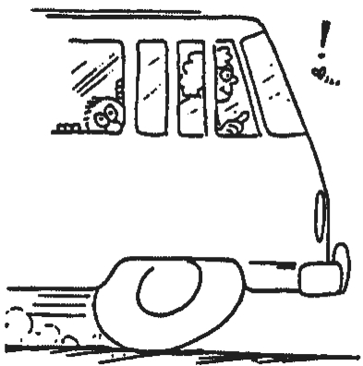
  - Force (F)? ___________________

  - Time (t) duration of the force? ___________________

  - Impulse (Ft)? ___________________

  - Momentum change (∆mv)? ___________________

  - Velocity change (∆v)? ___________________

  - Accleration (a) ___________________

  - Death () ___________________

- In the table below, fill in the numerical values for total momentum before and after the collisions of the two-body systems. Also fill in the blanks for velocity. Assume each car with its occupant has a mass of 200. kg.
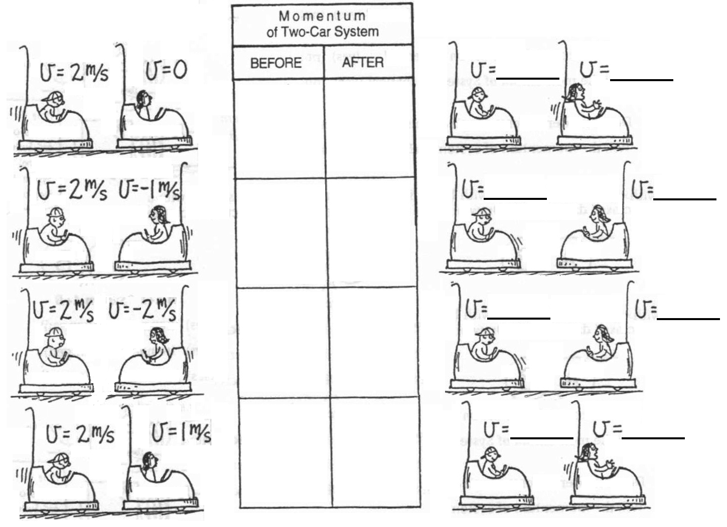

- A 60.0 kg quarterback running at 3.00 m/s east collides head on with a 100. kg lineman running 2.00 m/s the other way. What is their final velocity if they stick together?

