Practice – Conservation of Energy Model

- The KE & PE of a block freely sliding down a ramp are shown in one place on the sketch. Fill in the missing values.
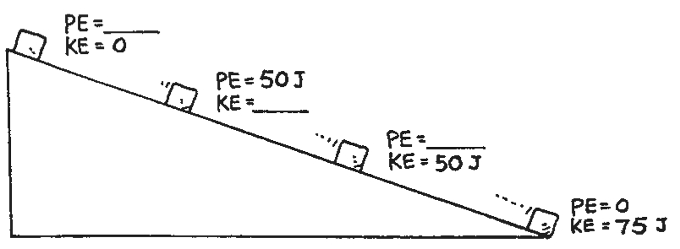

- Suppose you push a 8.00 kg block with a coefficient of friction of 0.800 in a horizontal direction with a force of 200. N. The block started with a speed of 1.00 m/s. how fast is it moving after 20.0 m? Show all work.

- You push a 10.0 kg block 5.00 m up an incline plane with a force of 100. N so that its final vertical high is 2.00 m. The block started at rest and at the end of 5.00 m it is moving with the speed of 5.00 m/s. What is the force of friction? Show all work.

