Objective: Model the relationship between output distance and input distance (put d_{in} on the y-axis); input force and output force (put F_{out} on the y-axis); and energy input and useful work output for a pulley. Sim found at http://gateway.golabz.eu/embed/apps/0907267a-b827-42d5-9788-999bbc8a87a4/app.html . Make sure you select the “moveable” pulley. When graphing, put d_{in}, F_{out}, and W_{useful} on the y-axes.

Diagrammatical:

Graphical:
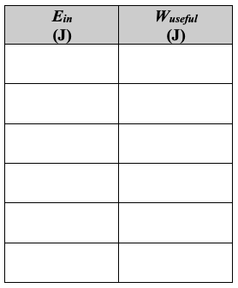
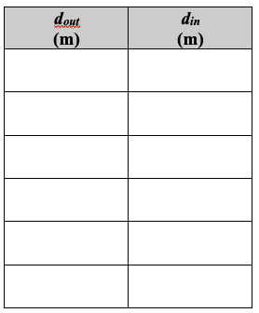
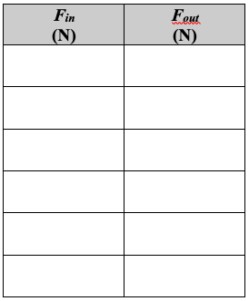

Mathematical & Word:

