Objective: Model the relationship between F_{AB} (read “Force of object A acting on object B) and F_{BA} (read “Force of object B acting on object A”). Phet Hooke’s Law lab found at https://phet.colorado.edu/sims/html/hookes-law/latest/hookes-law_en.html . Choose “Intro” from the home screen. In the upper right corner, check “Applied Force”, “Spring Force”, and “Values”. Use the grabbers to pull the spring. Let the action/reaction pair under investigation be the interaction between the grabbers and the spring.

Diagrammatical: Experimental Design:

Graphical:
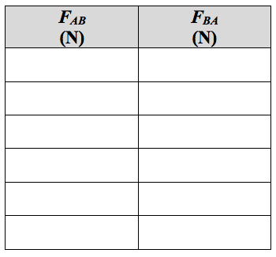

Mathematical:

Word:

