Practice - Inclined Planes

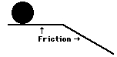
- Sarah’s eighth frame in the Wednesday night bowling league was a disaster. The ball rolled off the lane, passed through the freight door in the building's rear, and then down the driveway. Circle the velocity-time graph (A, B, C, or D) that would be an appropriate representation of the ball's motion as it rolls across the horizontal surface and then down the incline (friction is present).
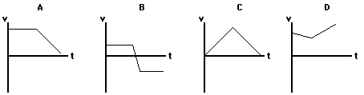

- Three lab partners are discussing an incline problem (see diagram). They are debating the value of the normal force on a 50.0 kg ball on an inclined plane propped at a 30° angle. Olive claims that the normal force is 250. N; Glen claims the normal force is 433 N; and Bill claims the normal force is 500. N. While all three answers seem reasonable, only one is correct. Indicate which two answers are wrong and explain why they are wrong.

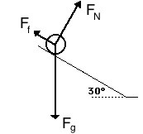

- A 100. kg box is sliding down a frictional surface tilted at 30.0° at a constant speed of 0.200 m/s. Showing all work (including a finished picture) solve for the weight, normal force, force of friction, parallel component of gravity, perpendicular component of gravity, coefficient of kinetic friction, and acceleration of the box.

